Range Date Picker task note
Yuanhao (Jim) Liu
University Of Waterloo
Task content:
Substitute all of the material table related date filter to range date picker

Task progress:
RangeDatePicker at AuditLog page has finished
- null value edge case handling
- format check
- CSS pattern
- Variable meaningful naming revise
but this component needs API change to be compatible with other pages.
All the other pages which use the date column has been added the comment at the commit 1b3034d6363c8a160f11649dc1a09e76475176df at 2023/4/27 by Yuanhao Liu in branch “branchOfJim”

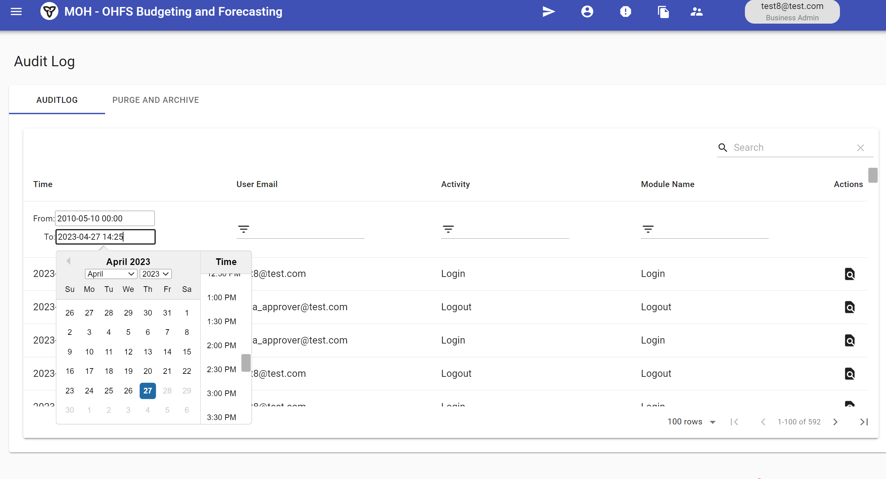”

Task Note:
The RangeDatePicker at AuditLog page used multiple special backend service. Depending on the use case, fetching both data sources (auditlogs and archivelogs) at once and then using the RangeDatePicker to filter the records can be more efficient. If the amount of data isn't huge and the fetching operation doesn't put too much load on the server or the user's device, then it can be a better approach.

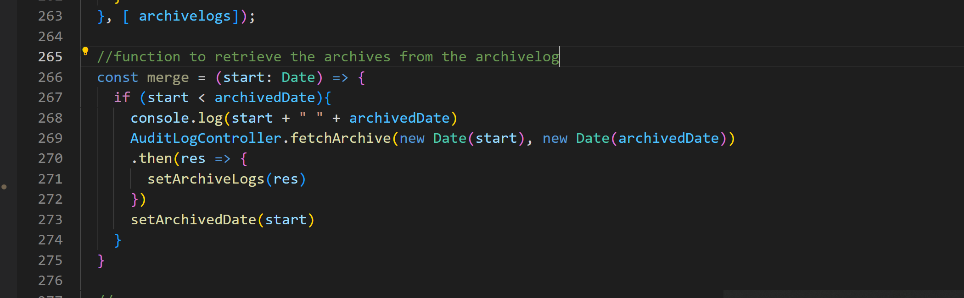
This step is using range fetch API to fetch range archive log for the merge use.

Given the size of the data (58,500 records) in AuditLog pages, fetching all records at once might not be the best approach. It can result in longer loading times, increased memory usage, and a less responsive user interface.

“Fetching data on-demand based on the date range selected by the user” approach ensures that only the necessary data is loaded, resulting in a more efficient and better-performing application. You can optimize the fetching process by implementing pagination and only loading a specific number of records at a time.

Remember, though, that this approach also has its trade-offs. Fetching data on-demand might require more frequent communication with the backend, which could cause additional server load. However, given the size of the data, it's generally a better choice for performance and user experience.

However, for other pages, they do not need to merge the 2 data source and they do not have range data fetch backend API. It would be required to have discussion with project manager to decide whether follow A or B method below for other pages based on the front end page design and the backend database record amount:
A. have backend API for every date change in RangeDatePicker to lower the workload, but the backend server need contact for each date change
B. store all of the record at once, and only filter the content from the full data in the client browser side

